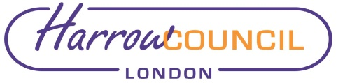
Legal & Governance Services
Director – Hugh Peart

Public Notice

Cabinet – 15 September 2022 at 6.30 pm
Pursuant to paragraph 5(4) & (5) of the Local Authorities (Executive Arrangements) (Meetings and Access to Information) (England) Regulations 2012, notice was given that the Cabinet may need to meet in private via the Key Decision Schedule, September to November 2022.

The previously listed report entitled “Fly-tipping Update” is now titled “Introduction of a Free Bulky Waste Collection Service and a Multi Online booking System for use of the Household Waste, Reuse & Recycling Centre”.

[For information, the Key Decisions advised via the Key Decision Schedule, September to November 2022 (published on 17 August 2022) are to be considered as set out on the Cabinet agenda.]

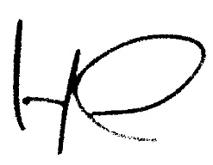
Director of Legal and Governance Services
Date: 7 September 2022

